DECLARATION

We hereby declare that this project report titled “Application of PLCs in Biscuit Sandwich Production Unit” is a record done by us during the PLC training period in the month of September, 2019 under the guidance of Mr. Debasish Mohapatra and Mr. Bhabani Shankar Swain.

The information and data given in this project is authentic to the best of our knowledge.

Thank you.

Abhishek Patra (1801106019)

Debanshu Samal (1801106193)

Gunjan Giri (1801106243)

Jogesh Mishra (1801106258)

Kshitij Srivastava (1801106270)

Prajojita Nayak (1801106328)

ACKNOWLEDGEMENT

We have taken efforts in this project. However, it would not have been possible without the kind support and help of our parents. We would like to extend our sincere thanks to them. We would also like to thank College of Engineering and Technology, Bhubaneswar for conducting the PLC training programme.

We are highly indebted to the training faculties of Central Tool Room and Training Centre for their guidance and constant supervision as well as for providing necessary information regarding the project & also for their support in completing the project.

We would like to express our special gratitude and thanks to our teachers Debasish Mohapatra and Bhabani Shankar Swain for giving us such attention and time.

ABSTRACT

PLC has evolved as an important controller in industries these days because of its simplicity and robustness. It is used for controlling many mechanical movements of the heavy machines or to control the voltage and frequency of the power supplies. The advent of the PLC began in the 1970s, and has become the most common choice for manufacturing controls. PLCs have been gaining popularity on the factory floor and will probably remain predominant for some time to come. The article starts with an overview of the history and the role of PLCs in factory automation.

In the coming sections of this project, the application of PLC in a Biscuit Sandwich Production Unit can be overviewed. Functions of different machinery with the help of PLC are also mentioned. After that a brief discussion of the advantages and disadvantages of PLC are given.

INDEX

1. History of PLC

2. What is PLC?

* Introduction
* Features of PLC
* Operation of PLC
* Communications in PLC
* Programming in PLC
* Need for PLC in Automation
* Applications of PLC
* Advantages of PLC
* Disadvantages of PLC

3. Biscuit Sandwich Production Unit

* Briefing About the Industry
* Industrial Production and Use of PLCs
* Program Description
* Schematic Diagram of the Process
* PLC Program in LADDER Language

4. Conclusion

5. Bibliography

History of the Programmable Logic Controller (PLC)

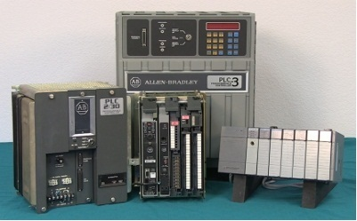 In the 1960s, the Programmable Logic Controller (PLC) was invented for the American automotive manufacturing industry used to replace re-wiring hard wired control panels with software program changes when production modifications were required.  Before the development of PLCs, thousands of relays, cam timers, drum sequencers and dedicated closed-loop controllers were used to manufacture automobiles.  The need to update the manufacturing process by re-wiring the relays and other components was very time consuming and expensive.  In 1968 GM Hydramatic requested a proposal for a replacement for the relay logic system.  Bedford Associates won the contract and designed the first PLC, the MOdular DIgital CONtroller (Modicon).  Dick Morley, one of the developers of the Modicon 084, is considered to the ‘father’ of the PLC.  The Modicon 084 PLC was designed to be programmed in ‘ladder logic’ which resembled the schematic diagrams of relay logic it was replacing.  This made the transition to PLCs easier for engineers and technicians.  The automotive industry is still one of the largest users of PLCs today.

In the early 1970’s communications between PLCs started to develop.  Modbus was introduced as the first industrial communications network.  This communication network was based on a Master/Slave architecture using messaging to communicate between Modbus nodes.  Its original interface ran on RS-232 but later implementations used RS-485 to allow for quicker communications that could run longer distances.  However, the lack of standardization and changing technology made PLC communications a nightmare.

In the 1980’s General Electrical attempted to standardize the interconnection of devices from multiple manufacturers with Manufacturing Automation Protocol (MAP).  PLC programming software was also developed to run on personal computers to eliminate the need for dedicated programming terminals or handheld programmers.

In the 1990’s there were less new communication protocols introduced and the latest standard (IEC 1131-3) tried to merge the PLC programming languages into on international standard. PLCs were also being programmed using functional block, instruction list and structured text and PCs started to replace the PLC in some applications.

PLCs have evolved over the years to include motion control, process control, distributed control systems (DCS) and complex networking. The PLC’s capacity for data handling storage, processing power and communication capabilities is about equivalent to the desktop computer.

The advantages of the PLC used in industrial control systems are:

* Cost effective for controlling complex systems.
* Adaptable. PLCs can be reprogrammed for different application quickly and easily.
* PLCs can be programmed to control complicated systems.
* Easier for engineers and technician to trouble shoot.
* Reliable. PLC systems can run for years before they need to be replaced.



WHAT IS PLC?

*Introduction:*

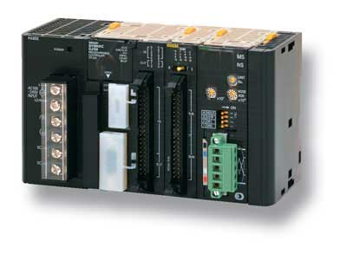 A programmable logic controller, commonly known as PLC, is a solid state, digital, industrial computer using integrated circuits instead of electromechanical devices to implement control functions. It was invented in order to replace the sequential circuits which were mainly used for machine control. They are capable of storing instructions, such as sequencing, timing, counting, arithmetic, data manipulation and communication to control machines and processes. PLCs are expected to work flawlessly for years in industrial environments that are hazardous to the very microelectronic components that give modern PLCs their excellent flexibility and precision. PLCs have from four to hundreds of input/output (I/O) channels in a wide variety of form factors, so size and power can be as important as system accuracy and reliability.

According to NEMA (National Electrical Manufacture’s Association, USA), the definition of PLC has been given as “Digital electronic devices that uses a programmable memory to store instructions and to implement specific functions such as logic , sequencing, timing, counting, and arithmetic to control machines and processes.”

*Features of PLC:*

The main difference from other computers is that PLCs are armoured for severe conditions (such as dust, moisture, heat, cold) and have the facility for extensive input/output (I/O) arrangements. These connect the PLC to sensors and actuators. PLCs read limit switches, analog process variables (such as temperature and pressure), and the positions of complex positioning systems. Some use machine vision. On the actuator side, PLCs operate electric motors, pneumatic or hydraulic cylinders, magnetic relays, solenoids, or analog outputs. The input/output arrangements may be built into a simple PLC, or the PLC may have external I/O modules attached to a computer network that plugs into the PLC.

*Operation of PLC:*

During program execution, the processor reads all the inputs, and according to control application program, energizes and de-energizes the outputs. Once all the logic has been solved, the processors will update all the outputs. The process of reading the inputs, executing the control application program, and updating the output is known as scan.

During the scan operation, the processor also performs housekeeping tasks.

The inputs to the PLCs are sampled by processor and the contents are stored in memory. Control program is executed, the input value stored in memory are used in control logic calculations to determine the value of output. The outputs are then updated.

The cycle consisting of reading of inputs, executing the control program, and actuating the output is known as “scan” and the time to finish this task is known as “scan time”. The speed at which PLC can scan depends upon the clock speed of CPU. The time to scan depends upon following parameter:-

• Scan rate • Length of the program • Types of functions used in the program

Faster scan time implies the inputs and outputs are updated frequently. Due to advance techniques of ASIC (application specific integrated circuit) within the microcomputer for specific functions, scan time of different PLCs have reduced greatly.

*Communications in PLC:*

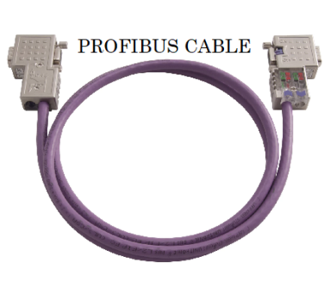

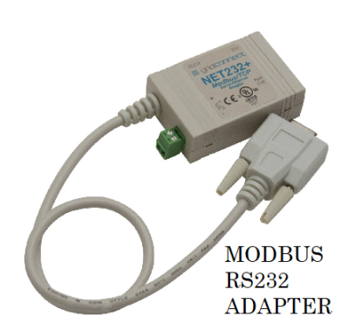 There are several methods how a PLC can communicate with the programmer, or even with another PLC. PLCs usually have built in communication ports for at least RS232, and optionally for RS 485, and Ethernet. Modbus is the lowest common denominator communication protocol. Others are various fieldbuses such as profibus, interbus-s, foundation field bus, etc.

In recent years, PLCs have been integrated in to industrial networks, and all the PLCs in an industrial environment have been plugged in to a network. The PLCs are then supervised by a control centre. There exist many types of networks, SCADA (supervisory control and data acquisition). With the advent of SCADA systems, Ethernet module is widely used for communication. It uses TCP/IP protocol for communication over a network of other devices (PCs, PLCs). It is given an RJ-45 connector to establish connections with the help of a CAT-5 Ethernet cable.

*Programming in PLC:*

Early PLCs, up to the mid-1980s, were programmed using proprietary programming panels or special-purpose programming terminals, which often had dedicated function keys representing the various logical elements of PLC programs. Programs were stored on cassette tape cartridges. Facilities for printing and documentation were very minimal due to lack of memory capacity. The very oldest PLCs used non-volatile magnetic core memory. The major advantage of PLC over the conventional devices is its ability to implement desired automation based on a user program. This program can be compiled by user on a PC and can be uploaded to the PLC. The manufacturer of PLC develops their own software to program the PLC, e.g., SIMATIC S7 by SIEMENS. The program can be written in following logics:

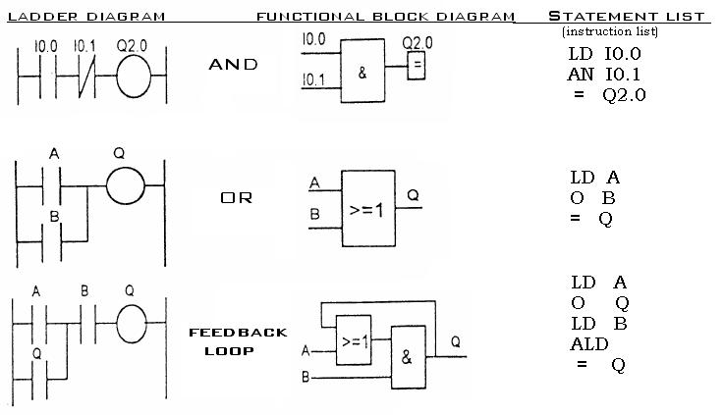 • Ladder Logic (LAD) - An ON-OFF switch and a relay coil are the basic components of this method. These symbols emulates the real life components used in an actual control system and thus LAD logic can be understood by person having little or no specific knowledge of programming. The switches used can be normally open type or normally closed type depending on their use. The entire program can be written using these symbols in separate lines. The complete program structure looks like a ladder hence the name.

• Statement Logic (STL) - In this method, logical statements are written as a program. Various keywords are used to represent various parameters in the program. Programmer need to have prior knowledge of these keywords in order to compile an accurate program to produce desired automation results.

• Functional Block Diagram (FBD) - This is a graphical programming language for a PLC. The block represents a function and is provided with input and output ports which can be connected to other blocks or input/output. The direction of signal through the blocks is fixed, i.e., from left to right.

*Need for PLC in Automation:*

1. [PLC](http://www.polytechnichub.com/programmable-logic-controller-plc/) is  used in the fully automated industries or plants or process, the actual processes handled and controlled by the controllers which are nothing but the programming logic controllers that means PLC plays a very important role in automation section.
2. PLCs constantly monitor the state of the systems through input devices and generate the control actions according to the logic given in the user program.
3. It is a heart of control systems, PLC monitors the state of the system through field input devices, feedback signals and based on the feedback signal PLC determine the type of action to be carried out at field output devices.
4. PLC provides easy and economical solution for many automation tasks like

* Operates control and monitoring.
* Co-ordination and communication.
* PID computing and control.
* Logic / sequence control

*Applications of PLC:*

Because of the versatility of PLC, it is used in various places for automation. In industries various processes needs to be controlled at every instant of time such as valve control, pressure control, robotic action, etc. It becomes tedious and infeasible for humans to control all such activities on their own. Thus relays were used to perform those activities. However, a relay can be used only for a specific and limited operation which makes their use bulky and uneconomic. On the contrary PLC having the ability to perform number of tasks by simply modifying the program has become a prominent device for automation of such activities. There are various places where a PLC can be used. Some of those are listed as below:

• Robotic arm in car manufacturing

• Air compressors

• Airport runway lighting control

• Traffic signal control

• Smoke alarm control

• Process valve control

• Textile equipment

• Vacuum pump system

Apart from these applications, PLC is widely used in automation of electrical power system. At electrical substations automatic reclosing, circuit breaker tripping, capacitor switching, etc. can be controlled with PLCs.

*Advantages of PLC:*

1. Multiple devices such as timers, memory shells, etc. are embedded in one

system which makes PLC very convenient and versatile to use.

1. PLCs are robust in nature and can be operated effectively in adverse external

conditions such as temperature, humidity, motion, etc.

1. PLCs are easily programmable and its programming language is easily

understood.

4. The interfacing between input and output is already done inside a PLC.

5. Interfacing with HMI makes the monitoring of inputs and outputs of a PLC

easy and convenient.

6. Complex operations can be performed easily.

*Disadvantages of PLC:*

1. A lot of hard wiring is required for connection of input and output devices.

2. Since PLC is a semiconductor device, it can’t be operated over a level of

temperature where it can’t sustain it.

1. Debugging with PLCs may become tedious as finding the fault is not very

easy.

4. Initial cost of PLC is high.

BISCUIT SANDWICH PRODUCTION UNIT

*Briefing about the Industry*

Biscuit making is a conventional activity in India and in many other countries. The biscuits are produced by organized sector in large quantities, however, unorganized sector having prominent share in market. Biscuits are made in many shapes and sizes with or without embossed designs or logos. They are of different flavours as well they may be coated with chocolate, sandwiched with a fat-based filling.

The biscuit manufacturing industry is growing at the rate of 8% per annum. Now with GST in place more growth will be in organized sector. The trend is to go for more variety, taste, healthy products and innovative packaging. The completion is also very much in this industry and therefore creativity and innovation in products and packaging will decide the growth of this sub-sector.  
  
*Industrial Production and Use of PLCs*

Now a days food processing industries are coming up with good quality of products due to automated plants, which are well equipped with PLC’s (Programmable Logic Controllers) at every stage. Basically PLC (Programmable Logic Controller) is a device, more precisely a system- which can control logical or sequential operation of events/device along with the associated inter locking conditions applicable for start/stop of that device.

PLC is the heart of PLC panel and a great amount of precaution is taken while collecting the details. PLC single-handedly controls many processes simultaneously which reduces the requirement of manpower and supply power consumptions. It also increases the accuracy and precision in bringing out the products. Therefore, nowadays it is the necessity of every process industry to be facilitated with PLC’s. Also there will be reduction in the time for the completion of product as well as hygiene and sanitation of plant will be maintained which is at top priority for any process industry.

Biscuit manufacturing consists of four major processes: mixing, forming, baking and packing. Mixing is a crucial process where shifted flour is mixed with other ingredients and additives in right proportion to form dough of right consistency as per type of biscuit to be produced. The mixing may be carry out in single or double or triple stages as per type of biscuit, ingredients and additives mixing characteristics and required consistency of dough for moulding. The mixed dough of required consistency is then fed on to the processing line where it is sheeted or laminated, then cut into required dimensions under rotary moulding machine followed by baking in four stage oven where every baking zone has different temperature to bake individual piece of biscuit to get right colour, taste and aroma. Thus baked biscuits are needed to cool properly in a well-designed cooling zone or belt. For making cream sandwiched biscuits, first cream is prepared with proper whooping, cream spreader is needed and then a special machine for packing of cream sandwiched biscuit is required to pack them.   
  
*Program Description*

This project revolves around the production unit concerning the preparation and packaging of double layered biscuit sandwiches using PLCs.  
 The unit starts with the arrival of biscuits on the conveyor belt. When the biscuit reaches the **“Cookie Present Sensor 1”**, it activates the **Switch S1**, the conveyor belt stops; the valve of the **“Cream Tank”** opens for 5 seconds **(governed by Timer T0 and T1)** till the adequate amount of cream has been dispensed on the biscuit. When the level of the cream in the Cream Tank falls below the Low Level, the entire process takes a pause and the “Cream Supply” starts running till the High Level Sensor detects the presence of the cream after which the process resumes. After the timer reaches its end value, the conveyor starts to move again. The conveyor stops when the **“Cookie Present Sensor 2”** detects the presence of the biscuit, thereby activating **Switch S2**. The valve of the **“Cookie Dispenser”** opens for a time of 7 seconds **(governed by Timer T2 and T3)** and a second biscuit is placed on top of the cream. When the number of biscuits in the Cookie Dispenser falls below the Low Level, the entire process takes a pause and the “Cookie Supply” starts running till the High Level Sensor detects the presence of the biscuit after which the process resumes. As the timer reaches its end value, the conveyor starts to move again. The belt halts again when the **“Cookie Present Sensor 3”** detects the presence of a biscuit. It activates the **“Stamper”** **(Sensor S3)** which presses the double layers of the sandwich together. After that the conveyor starts to move again. The **Counter C0** **(Sensor S4)** counts till 12 biscuits have been assembled in a packet. And the process continues to go on till the emergency stop button is pressed **(COM STOP).**

*Schematic Diagram of the Process*

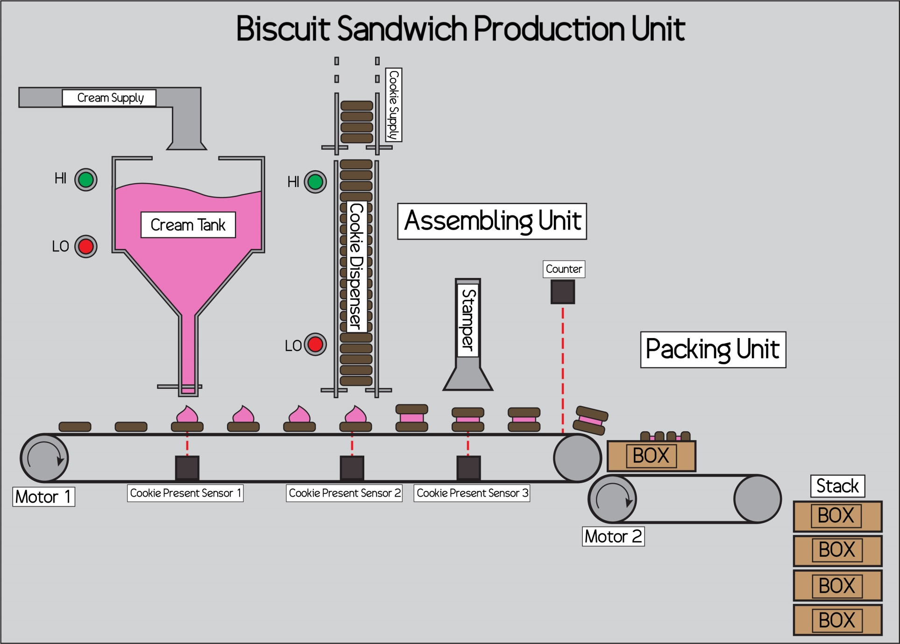

CONCLUSION

PLC was used to govern the process taking place in the Biscuit Sandwich Production Unit. Four Sensors (One Counter and Three Cookie Present Sensors) were used to govern Five Outputs (Two Motors, A Cream Dispenser, A Cookie Dispenser and A Stamper).

So, the implementation of the PLC was carried out effectively for various industrial applications. It proves to be one of the important controllers in industries for its simplicity and robustness and is used all over the world. For any control design approach understandings of the desired control system and how to use the ladder diagram to translate the machine sequence of operation are the most important parts, because it has direct effect on the system performance. PLC’s are very good for controlling outputs based on the inputs. They are amazingly robust and are able to withstand all sorts of difficult conditions such as extreme temperature or dust in the air. They last for a very long period. They don’t have contacts that wear out, like relays do. They also can switch fairly quickly without much heating in direct contrast to relays. For any application we need not to change the whole structure only different program has to be embedded as like any other programmable devices. Compared to relays PLCs are almost always a better choice.

BIBLIOGRAPHY

* https://unitronicsplc.com/what-is-plc-programmable-logic-controller/
* http://bridges.articlealley.com/functions-advantages-and-disadvantages-of-programmable-logic-controllers-plcs-1644253.html
* https://library.automationdirect.com/history-of-the-plc/
* https://ibrahim6060.weebly.com/history-of-plc.html
* https://www.polytechnichub.com/programmable-logic-controller-plc-automation/
* http://www.kronotech.com/PLC/